**Proposed Mortar Plaster for Cleaning Air Pollution**

**Assem Abdel Aliema, Hanaa I. El-Sayadb, Adel E. El-Ghalyc, SaharMoussad**

aProfessor of Properties and Testing of Materials, Civil Engineering Department, Faculty of Engineering at Shoubra , Benha University

bProfessor of Properties and Testing of Materials, Civil Engineering Department, Faculty of Engineering at Shoubra, Benha University

cLecturer, Civil Engineering Department, Faculty of Engineering at Shoubra, Benha University   
d PhD Candidate- Housing and Building National Research Center

**Abstract.**TiO2 is a primary photocatalytic ingredient. If incorporated into building materials, it can keep surfaces cleanand significantly reduce smog-forming air pollutants. Many of researchers have focused on the ability of nano TiO2 toreduce NOx emissions or other pollutants. However, developing countries are unable to utilize this high cost technology and should at least try to protect their structures from pollution and improve their environment.Some studies proved that micro TiO2(commercial grade) also has photocatalytic properties. Utilization of small amount of this powder in concrete would not be expensive. The effect of TiO2 on different properties of mortars is investigated including flow in the fresh state, compressive strength, shrinkage, sulfate resistance and carbonation. The results indicated that incorporating TiO2 in mortars decreased the workability as mortars became more sticky and dry as TiO2 percentage increased. The compressive strength was also reduced in TiO2 containing samples compared to the control samples especially at early ages.However, using TiO2powder as an additive in mortar can be useful for giving better performance such as reducing carbonation. No samples in the current investigation showed signs of cracking or expansive mass loss due to sulfate exposure. It is recommended that TiO2 is used as an additive to the mortar plaster to help in controlling the air pollution problem and at the same time improve air pollution problem.

**Keywords:** TiO2Powder; Carbonation;Compressive Strength; Shrinkage; Sulfate Resistance.

1. **INRODUCTION**

TiO2 is a primary photocatalytic ingredient and studies have shown that TiO2 incorporated into building materials can keep surfaces clean and significantly reduce smog-forming air pollutants (pollution abatement) [1].Researchers recognized the air purification potential of TiO2 for urban and metropolitan areas that suffer high air pollution concentrations [2, 3]. The number of TiO2patents is continually growing and currently include materials in concrete tiles, concrete paving, white cement (architectural concrete), applications on building surfaces, as well as applying environmentally-friendly cement (TioCem) [4, 5, 6].

An experimental program wasconducted to study the potential of using commercial grade TiO2 in road pavements/structures for NOxabatement. Concrete slabs were cast and TiO2 powder was spread on their surface before setting. The concrete slabs were cured from time to time with water spray for seven days. The slabs were tested in the laboratory in a specially built apparatus. The results showed thatthe NOx concentration decreased with time of exposure to the slab surfaces, which mean that commercial grade TiO2 was an effective photocatalyst [7].

A research was conducted to clarify the basic properties of mortar and concrete using TiO2 as an admixture. Experiments were carried out on the fresh properties, strength, drying shrinkage, and carbonation depth. By partially fine aggregates and/or cement with different TiO2 percentages, it was found that as the aggregate replacement amount of TiO2 powder increases, the compressive and flexural strength also increased. It was postulated that TiO2 possibly entered into capillary voids and filled the mortar. Declines in strength for “10%” and “20 %” were observed by the decreasing cement content, while replacing some cement with TiO2. However, it was also found that mortar with less than 10% TiO2 had almost the same carbonation depth as non-TiO2,despite a decrease in unit cement content. It wasconcludedthat using proper TiO2 powder as an admixture in mortar or concrete can be useful for giving additional performance such as brightness retention and self-cleaning effects on the surface, as well as strength development and crack control [8].

A research was conducted to study different TiO2 types from different manufactures to help identify which crystalline type, particle size, purity, and quantity of TiO2 would be the most appropriate product to add to the concrete matrix to create a photocatalytic, NOxreducing concrete surface. TiO2 powder used in that study were either commercially available as photocatalytic grade or other samples not manufactured for photocatalytic properties. It was concluded that only some TiO2 powder in the anatase phase had the ability to significantly decrease NOx pollutant concentrations. The effective anatase phases were approximately 1.0 μm in average size and had purities between 83 and 97%. The less effective anatase phase had a smaller particle size and greater than 98% purity. It was noted that the efficiency is greater if TiO2 is available near the surface of the material’s cross section, so that it can be activated by solar radiation. The work showed that coarser and less pure anatase TiO2 is an effective photocatalyst, and the optimum dose in the mix is below 9% by weight of cement [9].

A study was conducted on using micro-sized TiO2 powders for the photodegradation of pollutants NOx and toluene. It was found that all micrometric TiO2 powders, even though they are sold as not photocatalytic materials, showed good results. It was recommended that micro TiO2 powders should be used rather than nano TiO2 in order to reduce health problems associated with difficult recovery and consequently health hazards due to inhalation typical of nanoparticles [10].

The cited references above demonstrated that commercial grade TiO2 can be used on the outer layers of building materials, like plaster or decorative cement based paints, to produce an economic and health hazard free layer, having the ability to reduce urban pollution. However, some of the properties incorporating commercial grade TiO2in building plaster need to be further investigated to fully understand its effects on such mortars.

1. **EXPERIMENTAL PROGRAM**

The main purpose of this research was to investigate the properties of mortars containing commercial grade TiO2to be used for reducing urban pollution. The powder wasutilized as an additive in small quantity. If this additive is incorporated, its effect on various properties needs to be investigated to ensure that it shall not adversely affect any of the fresh and hardened properties of mortars. The experimental program has been developed to investigate the following:

1. The effect of TiO2 content on consistency of mortars in the fresh state.
2. The effect of TiO2 content on compressive strength.
3. The carbonation potential of TiO2 containing samples compared to samples without it.
4. The length change of mortars with and without TiO2 as an indication of shrinkage.
5. The behavior of mortars with and without TiO2exposed to Sodium Sulfate Solution.

**2.1MATERIALS**

Ordinary Portland Cement (OPC) used throughout the test program was Suez Cement (CEM I 42.5 N) having surface area of 3500 cm2/g and specific gravity of 3150kg/m3 conforming to the requirements of ESS 4756-1/2013 [11]. The chemical composition of the cement is shown in Table1.

Titanium Dioxide (TiO2)was in solid state (powder), having slight odor and white color. TiO2 with high purity was used. The physical properties of TiO2 as obtained from the manufacturer are illustrated in Table 2 and Figure1.Figure 2 for  [X-Ray Diffraction](https://www.googleadservices.com/pagead/aclk?sa=L&ai=DChcSEwiOkI30_-vVAhWHPhsKHX2wCWkYABABGgJ3bA&ohost=www.google.com.eg&cid=CAASEuRoxRMc_Ur0qAnFlYw3CAxtNw&sig=AOD64_13UDZFNDjnZO28edW9VRRkPnE-hA&q=&ved=0ahUKEwjQ9Yn0_-vVAhXC1xoKHQL5BWEQ0QwIKg&adurl=) analysis of TiO2, reveals that it is mainly anatase phase. Figure 3 shows the particle size distribution of TiO2 powder. Locally available natural sand was used as fine aggregate. The water used was the tap water.

**TABLE 1 Chemical Composition of Portland Cement**

|  |  |  |  |  |  |  |  |  |  |
| --- | --- | --- | --- | --- | --- | --- | --- | --- | --- |
| **Component** | SiO2 | Al2O3 | Fe2O3 | CaO | MgO | SO3 | Na2O | K2O | L.O.I |
| **Content (%)** | 20.39 | 5.6 | 3.43 | 63.07 | 2.91 | 0.7 | 0.38 | 0.35 | 2.06 |

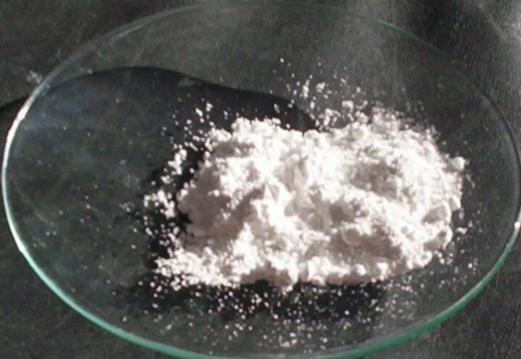

**FIGURE 1 Titanium Dioxide Powder Physical Appearance**

**TABLE 2 Physical Properties of TiO2**

|  |  |
| --- | --- |
| **Name** | **TiO2 powder** |
| Appearance | white |
| Particle size | 0.2912 - 0.6746 µm |
| Purity | 98 % |
| L.O.I | 0.13 % |

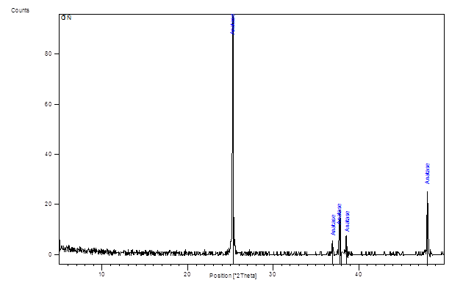

**FIGURE 2** [**X-Ray Diffraction**](https://www.googleadservices.com/pagead/aclk?sa=L&ai=DChcSEwiOkI30_-vVAhWHPhsKHX2wCWkYABABGgJ3bA&ohost=www.google.com.eg&cid=CAASEuRoxRMc_Ur0qAnFlYw3CAxtNw&sig=AOD64_13UDZFNDjnZO28edW9VRRkPnE-hA&q=&ved=0ahUKEwjQ9Yn0_-vVAhXC1xoKHQL5BWEQ0QwIKg&adurl=) **Analysis of TiO2**

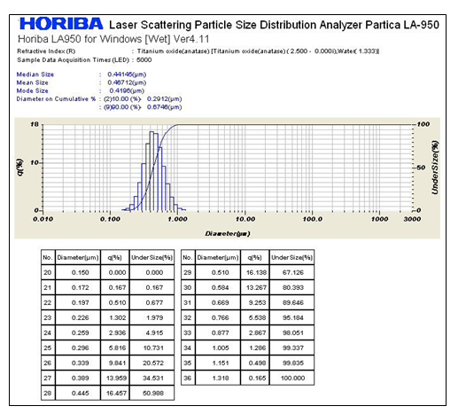

**FIGURE 3 Particle Size Distribution of TiO2 Powder**

**2.2MIXES DESCRIPTION**

A total of four mixes were prepared in the laboratory. The control mixwas prepared from natural sand, cement and water. The water to binder ratio for all mortars mixes was set at 0.50. The cement content of all mixes was 350kg/m3. The cement to sand ratio for all mixes was set at 1:3. Other mixes were prepared with different contents of TiO2 particles as an additive at 3%, 6% and 9% by weight of cement.A small electrical mixer was used for mixing mortars. The samples were cubes 50mm × 50mm × 50mm and prisms 25mm × 25mm × 285 mm. The specimens were cast and compacted in two layers using a plastic compacting bar, where each layer was compacted 25 times. Then the molds were placed on compacting table and vibrated for about 15 seconds. The molds were immediately covered with plastic sheet to avoid moisture loss, and were kept at room temperature (23 ± 2°C) for 24 hours. The specimens were then demoulded and were kept in water for seven days for moist curing.

**2.3TESTING PROCEDURES**

The tests performed were in accordance with ASTM standards as listed in Table 3.The details of the prepared cubes, prisms and tests performed are presented in Table4.

**TABLE 3 ASTM Standards for Tests**

|  |  |
| --- | --- |
| **Test** | **ASTM Standard No.** |
| Flow Table | ASTM C 1437 – 07 [12] |
| Compressive Strength | ASTM C109 / C109M - 16a [13] |
| Change in Length | ASTM C157 / C157M – 17 [14] |
| Sulfate Attack | ASTM C1012 / C1012M – 15 [15] |

**TABLE 4Details of Experimental Program**

|  |  |  |  |  |  |  |  |  |  |  |
| --- | --- | --- | --- | --- | --- | --- | --- | --- | --- | --- |
|  | **Test Program Table** | | | | | | | | | |
| **Fresh State** | | | | | | | | | |
| **Tio2 % added** | **Control** | **3%** | **6%** | **9%** | **Control** | **3%** | | **6%** | | **9%** |
| **Flow Test** | Repeat test 3 times for each mix, flow= average of 3 readings | | | | | | | | | |
| **Curing** | 7 days of Water Curing | | | | | | | | | |
|  | **Hardened State** | | | | | | | | | |
|  | Specimens in Air | | | | Specimens in CO2 | | | | | |
| **Control** | **3%** | **6%** | **9%** | **Control** | | **3%** | | **9%** | |
| **Carbonation**  **Resistance** | carbonation resistance only for samplesin CO2Chamber | | | | Test 3 cubes at each 28, 56, 90 days | | Test 3 cubes at each 28, 56, 90 days | | Test 3 cubes at each 28, 56, 90 days | |
| **Compressive Strength test** | Test 3 cubes at each 28, 56, 90 days | Test 3 cubes at each 28, 56, 90 days | Test 3 cubes at each 28, 56, 90 days | Test 3 cubes at each 28, 56, 90 days | Compressive strength of samples only for samples kept in air | | | | | |
| **Shrinkage Test** | Test 5 prismsat ages 28, 56, 90 days | Test 5 prismsat ages 28, 56, 90 days | Test 5 prismsat ages 28, 56, 90 days | Test 5 prismsat ages 28, 56, 90 days | Shrinkage test  of samples only for samples kept in air | | | | | |
| **Sulfate Attack** | Sulfate Attack  of samples only for samples kept in sulfate solution | | | | Specimens in Sulfate Solution | | | | | |
| **Control** | **3%** | | **6%** | | **9%** |
| Test 5 prisms at ages 28, 56, 90 days | Test 5 prisms at ages 28, 56, 90 days | | Test 5 prisms at ages 28, 56, 90 days | | Test 5 prisms at ages 28, 56, 90 days |

**3 RESULTSandDiscussion**

**3.1FLOW TABLE TEST**

As shown in Figures 4 and 5 for the flow test results, themortar consistency decreased as TiO2 percentage increased. The reason may be thatTiO2 is hydrophilic material (the capability of TiO2 to absorb the mixing water). So the increasing in TiO2 content in a mortar mix leads to reduction in observed flow diameter [16].The flow is defined as the percentage increase in the average diameter of the spread mortar (D in cm), over the original diameter of the base (10 cm). The percentage expresses the degree of mortar consistency

Flow = (D-10) X 100

10

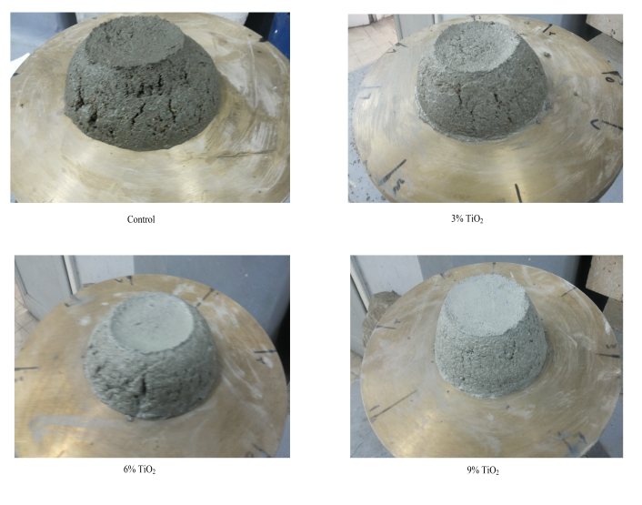

**FIGURE 4 Flow Table Test of Mortars**

**FIGURE 5 Flow Table Test Results of Mortars**

**3.2COMPRESSIVE STRENGTH OF MORTAR CUBES**

Figure 6and Figure 7 show the average compressive strength of all samples at the ages of 28, 56 and 90 days. The compressive strength decreased by increasing the amount of TiO2 except for 6% TiO2 mortars. In fact there is some improvement in compressive strength of 6% TiO2 at the later age of 90 days. For mixes with 6% TiO2, strength was better than 3% and 9% TiO2. By increasing TiO2 to 9%, the compressive strength was decreased by 39.9%, 30.5%, and 6.5% at ages 28, 56, and 90 days respectively compared to the control mix. This may be attributed to the possibility that the TiO2 content in mixture was higher than the amount required to combine with the liberated lime during the process of hydration thus causing a deficiency in strength [16]. The increase in TiO2 does not contribute to strength. Also, it may be due to the defects generated in dispersion of TiO2 that causes weak zones [16]. Figure 7 shows the ratio of strengths between TiO2 mortar specimen and control specimen. It is clear that at later ages the difference in strength between samples with and without TiO2was small.

**FIGURE 6 Compressive Strength Results of Cubes**

**FIGURE 7Ratio of Strengths between TiO2 mortar Cubes and Control Cubesat Various Ages**

**3.3CARBONATION RESISTANCE**

Figure 8illustrates the observations upon the application of Phenolphthalein Indicator to determine the effect of percentages of TiO2 powder (control, 3% and 9% as shown in Table 4)on the carbonation of mortar cubes exposed to CO2 gas for 28, 56, and 90 days. It can beseenthat the carbonation depth decreased as TiO2 percentagesincreased. The carbonation depth of control samples was increased with long exposure to CO2 gas. However, the presence of TiO2 significantly reduced CO2 depth especially at later ages.

Theimprovement in carbonation resistance with the inclusion of TiO2can be observed clearly after 28 days of curing. Similarly SEM test results had previously concluded that the incorporation of nano-TiO2 particles refines the microstructure and improves the carbonation resistance [17].

|  |  |  |
| --- | --- | --- |
| **Control** | Description: Description: control(1)  **Control** | Description: Description: control(2)  **Control** |
| **3% Tio2** | Description: Description: 2%(1)  **3% Tio2** | Description: Description: 2%(2)  **3% Tio2** |
| **9% Tio2** | Description: Description: 10%(1)  **9% Tio2** | Description: Description: 10%(2)  **9% Tio2** |
| 1. **28 Days** | 1. **56 Days** | 1. **90 Days** |

**FIGURE 8Phenolphthalein Indicator for Carbonation Test at Different Ages(a) 28 Days (b) 56 Days (c) 90 Days**

**3.4CHANGE IN LENGTH AS AN INDICATION OF SHRINKAGE**

Figures9 and 10 show the average of change of length for test prismskept in laboratory airfor 90 days. Five samples were tested for each mix. The change in length was determined as the following:

% Change in Length = L0- L1 x 100

L0

Where:

L0=Length of specimen after water curing.

L1=Length of specimen at a specified test age

It can be seen that the percentage change in lengthslightly increased with increasing TiO2content at all ages. Naturally, the shrinkage increased with time.In a previous investigation, it was found that thedrying shrinkage of concrete with nanoTiO2 was significantly higher than that for ordinary concrete without TiO2. The concrete specimens with 1% nanoTiO2 by weight of binder had the highest drying shrinkage rate compared to the ordinary concrete [18]. Figure 10 indicates that the TiO2 percentage had small effect on length change values as all samples with TiO2exhibited similar shrinkage at 90 days.



**FIGURE 9 Percentage Change in Length of Prisms Kept in Air**



**FIGURE 10Percentage Change in Length of Prisms Kept in Air at Different Ages**

**3.5RESISTANCETO SULFATE ATTACK**

Figures 11 and 12 show the average of change of length test prisms during 90 days sulfate solution exposure. Five samples were tested from each mix. It can be observed that the expansion of mortar prisms was decreased by increasing TiO2 percentage at all ages except for 9% TiO2. The 9% TiO2 mortar prisms were shrinking in sulfate solution.Table 5shows the percentage mass loss of prisms kept in sulfate solution. The table shows that the shrinkage of 9% TiO2 samples was not due to mass loss. In fact no samples exhibited cracking in the current investigation.

**FIGURE 11 Percentage Change in Length of Prism Kept in Sulfate Solution**

**FIGURE12 Percentage Change in Length of Prism Kept in Sulfate Solution at Different Ages**

**TABLE 5Percentages Mass Loss of Prisms Kept in Sulfate Solution**

|  |  |  |  |
| --- | --- | --- | --- |
| Mix | 28 Days | 56 Days | 90 Days |
| Average for Control | 0.50% | 0.86% | 0.69% |
| Average for 3% TiO2 | 0.50% | 0.86% | 0.69% |
| Average for 6% TiO2 | 0.47% | 0.25% | 0.08% |
| Average for 9% TiO2 | 0.40% | 0.10% | 0.06% |

**4. CONCLUSIONS**

1. The addition of TiO2 reduces the flow of the mortar mixes measured in accordance with ASTM: C 1437– 07.
2. The compressive strength of mortars was tested in accordance with ASTM C109/C109M-16a and was reduced with inclusion of TiO2, but this decrease in strengths was less noticeable at later ages.
3. The samples kept in laboratory air all exhibited comparable shrinkage.
4. By storing the samples in the proposed built CO2 chamber for up to 90 days, the samples containing TiO2 showed small or no carbonation depth. However carbonation occurred in the control samples.
5. Samples with 3% TiO2 exhibited similar behavior to the control samples when exposed to sulfate for up to 90 days. The test was conducted ina accordance with ASTM C1012-04. Samples with higher TiO2 exhibited better performance compared to the control samples without TiO2. No samples in the current investigation showed signs of cracking or expansive mass loss due to sulfate exposure.
6. It is recommended that TiO2should be used as an additive to the mortar plaster to help in controlling the air pollution problem. However, the mortar with TiO2 would need tobe optimized for consistency and compressive strength to be used effectively and cost of employing TiO2 as an additive to mortar.

**ACKNOWLEDGMENT**

The authors would like to thank Prof. NabeelMilad and technical staff at the National Housing and Building Research Centre for helping with the laboratory test setup.

1. **REFERENCES**
2. Italcementi Group: Technical Report-2008, “Tx Active: The Photocatalytic Active Principle”, <http://txactive.us/>,
3. Poon, C.S., and Cheung, E., "NO Removal Efficiency of Photocatalytic Paving Blocks Prepared with Recycled Materials" Construction and Building Materials, V. 21, No. 8, 2007, pp. 1746-1753.
4. Hassan, M.M., Mohammad, L.N., Cooper S.B., Dylla, H., “Evaluation of Nano-Titanium Dioxide Additive on Asphalt Binder Aging Properties” Journal of the Transportation Research Board , 2011, pp.11-15.
5. TioCem, “Innovative Building Materials - Reduction of Pollution with TioCem”, Light Southwest Cement, http://www.lehighpermanente.com/tiocem-new, Accessed November 2010.
6. Yoshihiko, M., K. Kiyoshi, T. Hideo, O. Hiroshi, and Y. Yutaka. “NOx Removing Pavement Structure”, US Patent Office, Patent No. 6454489, 2002.
7. Heidelberg Cement AG. TioCem® - High Tech Cement for the Reduction of Air Pollutants, Heidelberg, Germany, 2008.
8. Chen, Daniel H.; Li, Kuyen, “Photocatalytic Coating on Road Pavements/Structures for NOx Abatement”, Texas Air Research Center, Lamar University, Beaumont, TX.January 2007.
9. Hasebe, M., Edahiro, H., “Experimental Studies on Basic Properties of Concrete Using TiO2 as Admixture”, Hokkaido University Collection of Scholarly and Academic Papers, HUSCAP, 2013.
10. Hanson, S.,” Evaluation of Concrete Containing Photocatalytic Titanium Dioxide”, PhD Thesis, Department of Civil and Environmental Engineering, University of Utah, May 2014.
11. Gatto, S., “Photocatalytic Activity Assessment of Micro-sized TiO2 used as Powders and as Starting Material for Porcelain Gres Tiles Production”, PhDThesis, Department of Chemistry, University of Milano, Italy, 2014.
12. Egyptian Standard Specification 4756-1/2013. Cement part (1) Composition, Specifications and Conformity Criteria for Common Cements, 2013.
13. ASTM C 1437–07: Standard Test Method for Flow of Hydraulic Cement Mortar, 2007.
14. ASTM C109/C109M-16a: Standard Test Method for Compressive Strength of Hydraulic Cement Mortars (Using 2-in. or [50-mm] Cube Specimens), 2016.
15. ASTM C157/C157M–17:Standard Test Method for Length Change of Hardened Hydraulic-Cement Mortar and Concrete.
16. ASTM C1012 / C1012M – 15: Standard Test Method for Length Change of Hydraulic-Cement Mortars Exposed to a Sulfate Solution.
17. Khalafalla, M., S., Osama, A., H., Adam, I., A., “Improving The Mechanical Properties of Cement Mortar By Nano Titanium”, Journal of Engineering Sciences, Assiut University, Faculty of Engineering, Vol. 43, No. 5, September 2015, pp. 663- 681.
18. Duan, P., Yan, C., Luo, W., Zhou, W., “Effects of Adding Nano-TiO2 on Compressive Strength, Drying Shrinkage, Carbonation and Microstructure of Fluidized Bed Fly Ash Based Geopolymer Paste”, Construction and Building Materials, Volume 106, 2016, pp. 115–125.
19. Zhang, M. H., and Wang, H., G., "Strength and Drying Shrinkage of Pavement Concrete with NanoParticles", Advanced Materials Research, Vol. 662, 2013, pp. 182-185.